Mateen Olanrewaju April-6-2022

**Project 3**

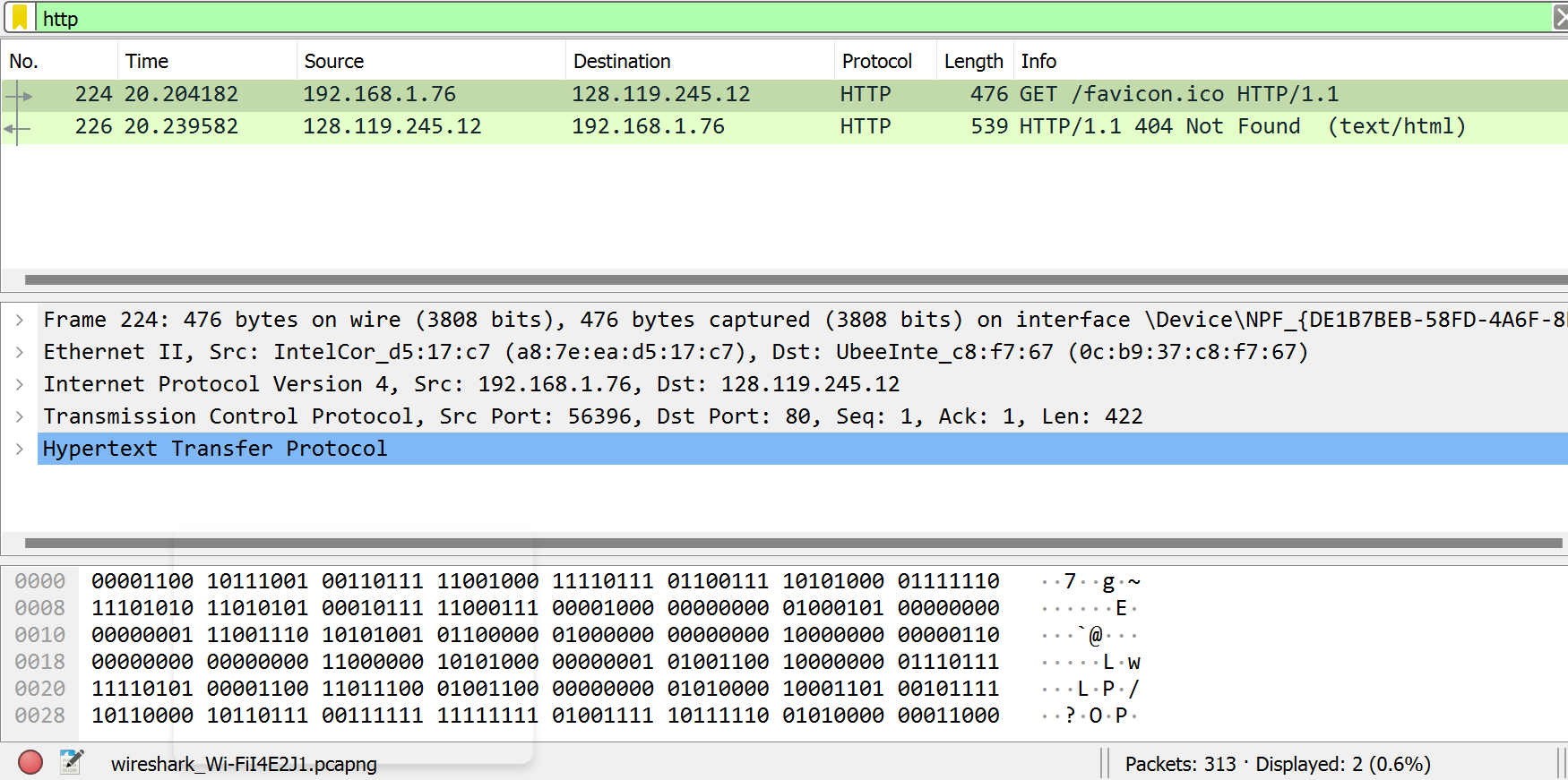

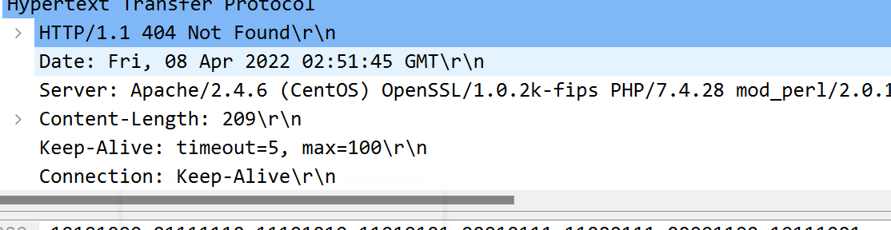

1. **My browser is running in HTTP version 1.1**

**The server was also running in HTTP version 1.1**

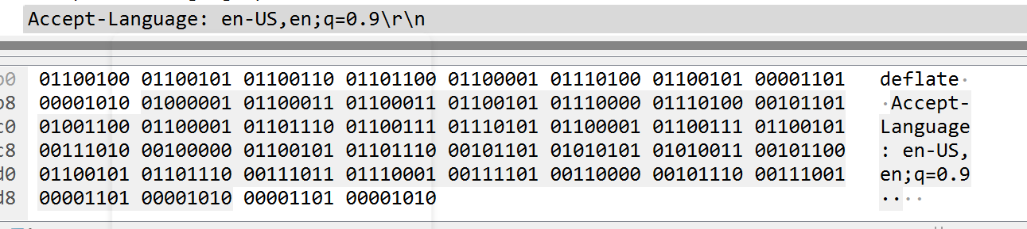

1. **My browser indicated that it can accept US English.**



1. **My IP address for my computer is 192.168.1.76**



1. **The status code returned was 128.119.245.12**



1. **Date Modified was April 08 2022 on Friday.**



1. **209 bytes of content are being returned to your browser.**



1. **All the information is displayed. I don’t see any header within the data that are not displayed in the packet-listing window because when I click on each information it gives me a blue highlighted section in the packet- listing window.**

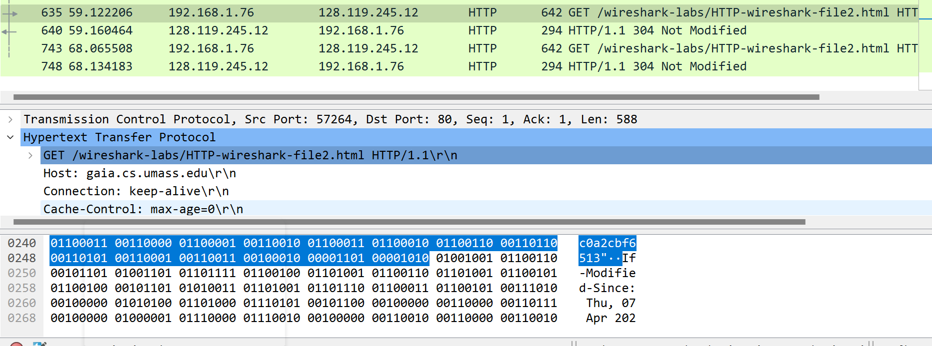

1. **Yes, I see an IF-Modified-Since line in the HTTP GET.**

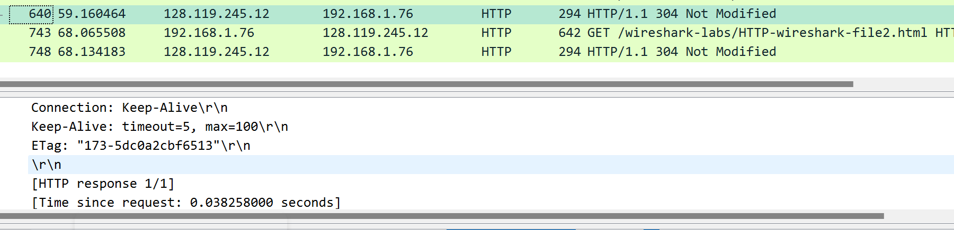

1. **No, the server did not return the content of the file I could tell because I went and look at it but I didn’t see it even after trying it the second time.**

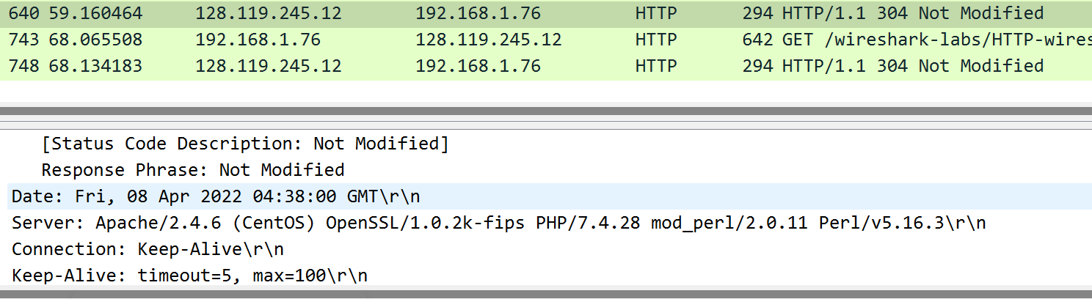

1. **No, I didn’t see the IF-Modified-Since line in the HTTP GET.**

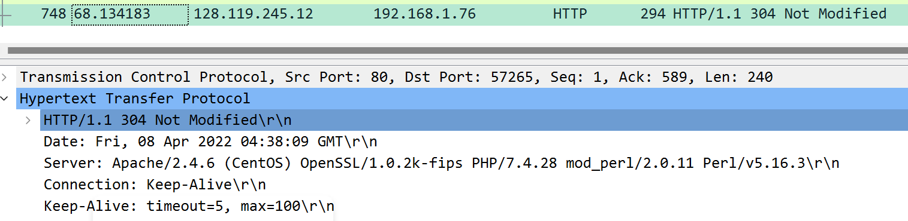

1. **The HTTP status code was 304 and phrase returned was Not Modified.**

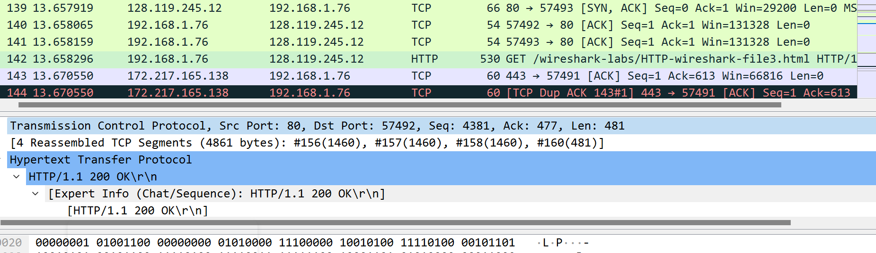

1. **Only one HTTP GET request message and packet number 142 contains the GET message.**

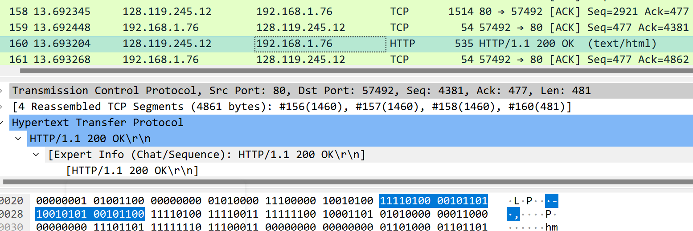

1. **The packet number in the trace contains the status code and phone associated is packet number 160.**



1. **The status code is 200 and the phrase is OK in the response.**

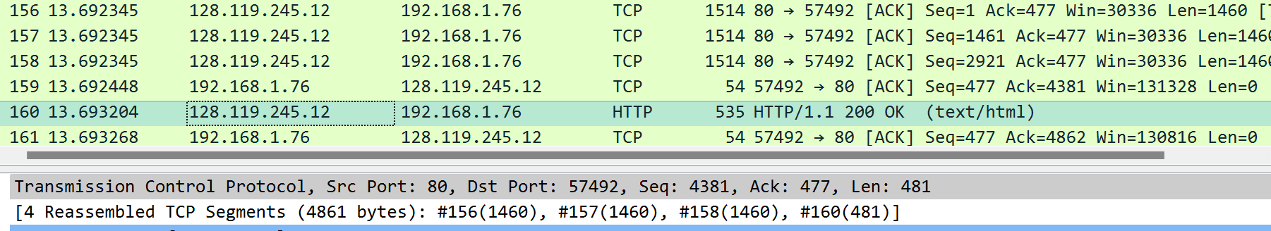

1. **They are 4 data-containing TCP segment which are 156,157,158,160.**

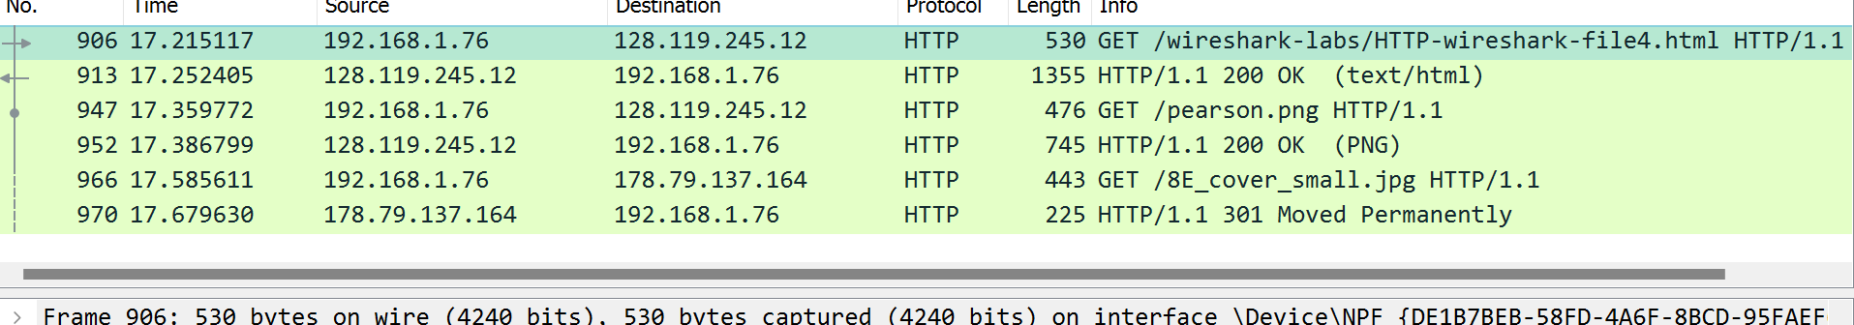

1. **They are 3 HTTP GET request messages. And the Get requests are sent to IP address 192.168.1.76**